*Most commonly used status codes are:****200****— success/OK****201****— CREATED — used in POST or PUT methods.****304****— NOT MODIFIED — used in conditional GET requests to reduce the bandwidth use of the network. Here, the body of the response sent should be empty.****400****— BAD REQUEST — This can be due to validation errors or missing input data.****401****— FORBIDDEN — sent when the user does not have access (or is forbidden) to  
the resource.****404****— NOT FOUND — Resource method is not available.****500****— INTERNAL SERVER ERROR — server threw some exceptions while running  
the method.****502****— BAD GATEWAY — Server was not able to get the response from another  
upstream server.*

**Use query parameters for filtering, sorting, and searching-**

***Query parameters****allow you to provide additional information in the URL of an HTTP request to control the response returned by the server.*

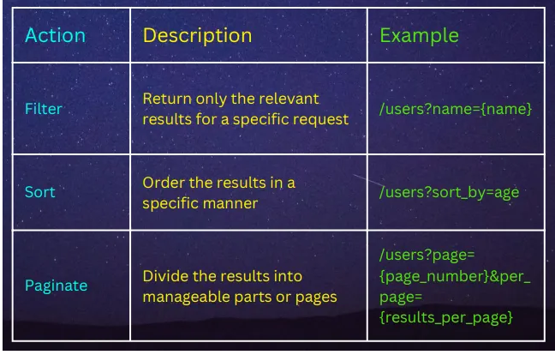

# Implement authentication and authorization-

*Secure your APIs by implementing proper authentication and authorization mechanisms.*

***=>USE API KEYS, TOKENS, OR OAUTH 2.0 FOR AUTHENTICATION***

***=>APPLY ROLE-BASED ACCESS CONTROL (RBAC) FOR AUTHORIZATION***

# Document your APIs-

*Provide comprehensive documentation for your APIs, including endpoint details, request/response examples, and usage guidelines .*

***=>SWAGGER/OPENAPI DOCUMENTATION***

***=>MARKDOWN-BASED DOCUMENTATION (E.G., USING TOOLS LIKE SWAGGER UI OR REDOC)***